Data Analytics Project 1

1. Begin with a city or town in the continental US that is interesting to you.

Maplewood New Jersey postal code is my home town and there for interest me.

2. Lookup its zip code (postal code).

07040 is the Zip code

3. Locate the entries in the data for your zip code of interest. Note that there is more than one entry for each zip code.

Found



4. Using tools from the internet (http://maps.huge.info/zip.htm), determine all of the neighboring zip codes adjacent to the zip code for your city of interest

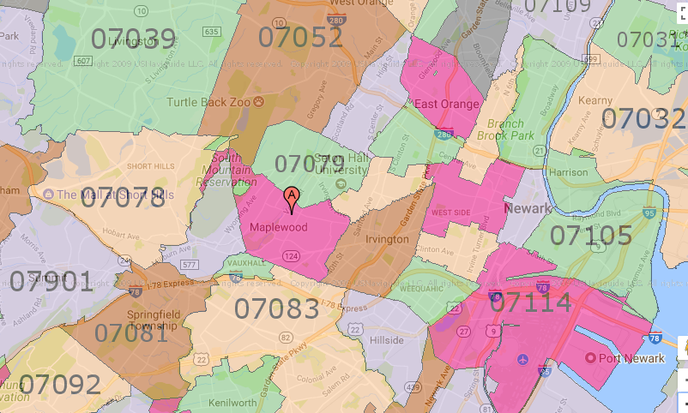

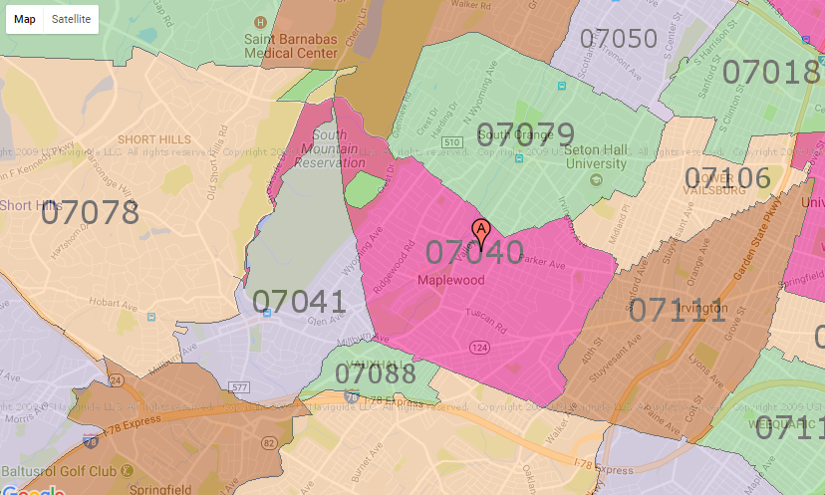

(07078- Short Hills, NJ)—10964 (07041-Milburn, NJ) -- 8530

(07088- Vauxhall, NJ) --8560 (07083- Union, NJ) ---99957

(07111- Irvington, NJ) ---- 176,083 (07106-Newark, NJ) ----- 85,862

(07079- South Orange, NJ) --19697 (07052-West Orange, NJ) –82,807

(07040- Maplewood NJ)---------- 36,145

5. Locate the entries in the data for all the neighboring zip codes.

(07106-Newark, NJ)

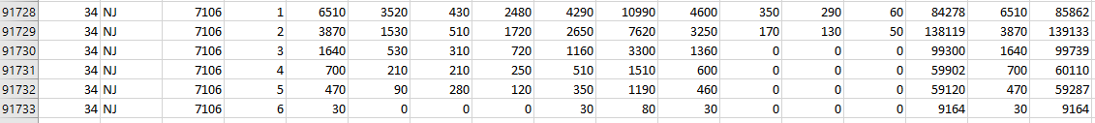

[85862 139133 99739 60110 59287 9164]

(07111- Irvington, NJ)

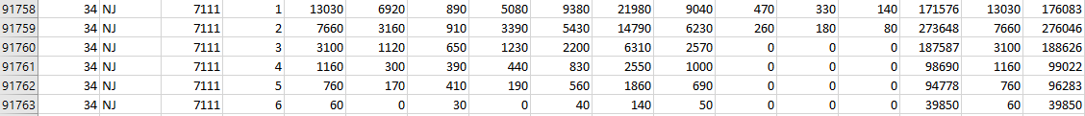

[176083 276046 188626 99022 96283 39850]

(07088- Vauxhall, NJ)

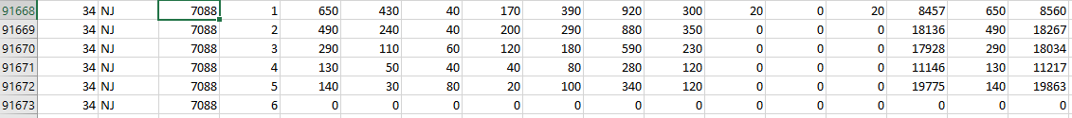

[8560 18267 18034 11217 19863 0]

(07083- Union, NJ)

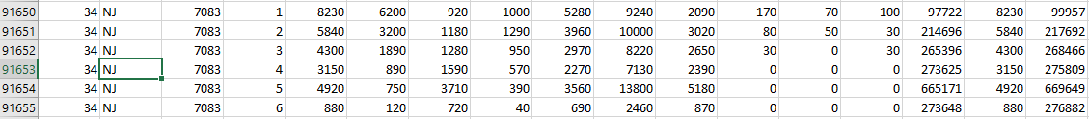

[99957 217692 268466 275809 669649 276882]

(07079- South Orange, NJ)

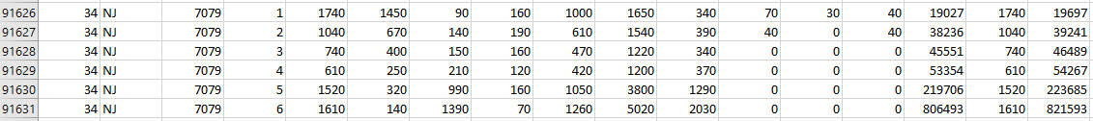

[19697 39241 46489 54267 223685 821593]

(07078- Short Hills, NJ)

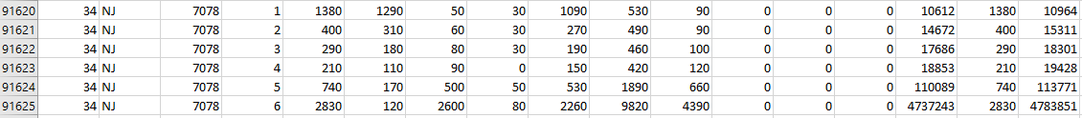

[10964 15311 18301 19428 113771 4783851]

(07052-West Orange, NJ)

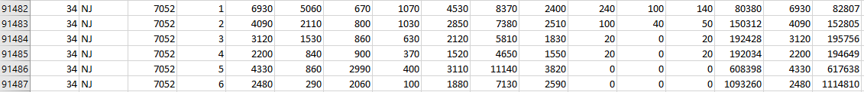

[82807 152805 195756 194649 617638 1114810]

(07041-Milburn, NJ)

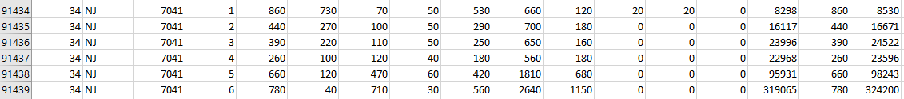

[8530 16671 24522 23596 98243 324200]

(07040- Maplewood NJ)----------

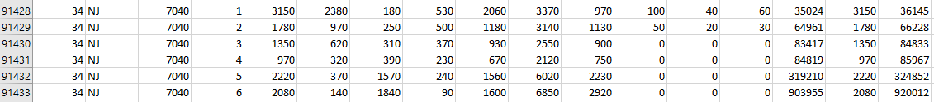

[36145 66228 84833 859667 324852 920012]

6. Design a visualization that describes the Total Income for the city of interest’s zip code and the surrounding zip codes. For this, you are free to select other features (i.e. N1, MARS1/MARS2.MARS4, etc.).

“**AGI_STUB”**

1 people who earn = $1 under $25,000  
2 people who earn = $25,000 under $50,000  
3 people who earn = $50,000 under $75,000  
4 people who earn = $75,000 under $100,000  
5 people who earn = $100,000 under $200,000  
6 people who earn = $200,000 or more

**A02650 --- Q**

(07078- Short Hills, NJ)—10964 (07041-Milburn, NJ) -- 8530

(07088- Vauxhall, NJ) --8560 (07083- Union, NJ) ---99957

(07111- Irvington, NJ) ---- 176,083 (07106-Newark, NJ) ----- 85,862

(07079- South Orange, NJ) --19697 (07052-West Orange, NJ) –82,807

(07040- Maplewood NJ)---------- 36,145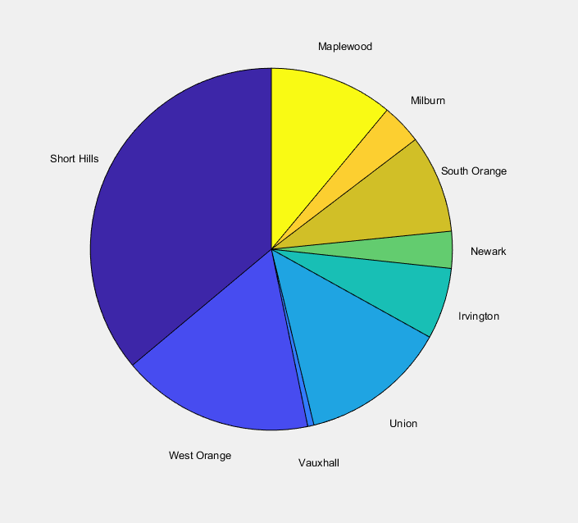

7. Discuss what you think your visualization means.

Proportions based on the amount of people who live in a given area and how much they make. On average the people who live in the bigger pieces of the pie have property that cost a greater amount. This has greatly to do with the populations to wealth ratio for example short hills has a smaller population but the overbearing cost drives the pie chart way out of portions. So most of the area has a high cost of living and very few space capable of holding anyone that makes less the 25000. On the other side Newark is highly populated but its filled with people that on average have a lower income. So it doesn’t even receive as much income from the 200,000 and above bracket simply because many of they don’t live there.